**Career Compass : A Path Finder and personalized career Guidance for students and Youngsters**

**ANBARASU.M1 , E. PANDIAN2**

1. II MCA, SRI MUTHUKUMARAN INSTITUTE OF TECHNOLOGY, MANGADU, CHENNAI.
2. HEAD OF DEPARTMENT, DEPARTMENT OF MCA, SRI MUTHUKUMARAN INSTITUTE OF TECHNOLOGY, MANGADU, CHENNAI.

**ABSTRACT:**

In the modern, rapidly changing world, many applications and websites assist people and youngsters in various ways, both in their work and for entertainment purposes. While numerous educational applications have evolved to support students, this new invention, Career Compass, guides students in choosing their courses based on their interests and qualifications. Additionally, it helps young people seeking jobs in the government sector by providing details about various exams offered by both state and central governments in India, according to their eligible age and educational qualifications. This is a one-stop solution for selecting the right path for education and career.

**KEYWORDS:**

1. UEQ- User Educational Qualification, 2. Api key.

1. **INTRODUCTION:**

Career Compass is an Innovative Student and Youngster Consulting or Suggesting application platform designed to provide users with an enriched Collection of Courses and exam-related data which are collected, processed, and Organized in an understandable and readable format to maintain a user-friendly interface. There is also an AI Assistant which is the model provided by Meta namely Llama which is integrated into this Career Compass by using the API key also this AI (Artificial Intelligence) model is restricted with Keywords containing education-related words so the model inside the application is not misused.

The existing system of Career Compass cannot provide organized and structured information to its users. This deficiency results in students facing difficulties in accessing relevant career guidance tailored to their age and educational qualifications. The disorganized data presentation leads to confusion and inefficiency, hindering the primary goal of assisting students in making informed decisions about their future. A more refined approach is essential to enhance the user experience, ensuring that information is presented in a clear, logical manner, thereby empowering students to navigate their career options with confidence and ease.

In the Proposed System, Career Compass excels in delivering organized and structured information to its users. This advanced approach ensures that students can effortlessly access relevant career guidance tailored to their age and educational qualifications. The well-organized data presentation eliminates confusion and inefficiency, successfully aiding students in making informed decisions about their future. By presenting information clearly and logically, the system significantly enhances the user experience, empowering students to explore their career options confidently and easily. This refined approach fulfills the primary goal of guiding students toward a successful future.

**2. RELATED WORKS:**

A Hybrid Approach for Career Path Recommendation Based on User Profile and Job Market Trends. This paper explores a hybrid recommendation system combining user profiles with job market trends. [1].

This paper explores a hybrid recommendation system combining user profiles with job market trends. Discusses using machine learning to adapt career guidance systems to user preferences and aspirations [2].

Career Path Prediction and Recommendation Using Data Mining Techniques Focuses on predicting and recommending career paths using data mining techniques. [3].

Web-Based System for Career Counselling Using Natural Language Processing and Text Mining Develop a web-based career counseling system using NLP and text mining [4].

A Recommender System for Career Guidance Using Collaborative Filtering and Content-Based Approaches Presents a recommender system combining collaborative filtering with content-based methods [5].

Design and Implementation of an Online Career Counselling Platform: A Practical Approach Explores the use of AI and big data analytics in career guidance systems. [6].

**3.** **PROBLEM STATEMENT:**

In today’s rapidly evolving world, students face significant challenges in selecting suitable educational and career paths due to the overwhelming amount of information available and the need for personalized guidance. Existing educational platforms often provide generalized advice that does not consider individual qualifications, interests, and specific career opportunities, especially within the government sector. Moreover, students seeking careers in government positions struggle to find comprehensive and up-to-date information about relevant exams and eligibility criteria.

**4.IMPLEMENTATION OF MULTI CHAT AGENT AI-CHAT APPLICATION:**

The implementation of the Career Compass, A path Finder and Career Guidance application is described in detail below using the flow diagram.

Figure 1 shows the workflow diagram that performs tasks that take place to run the Career Compass application.

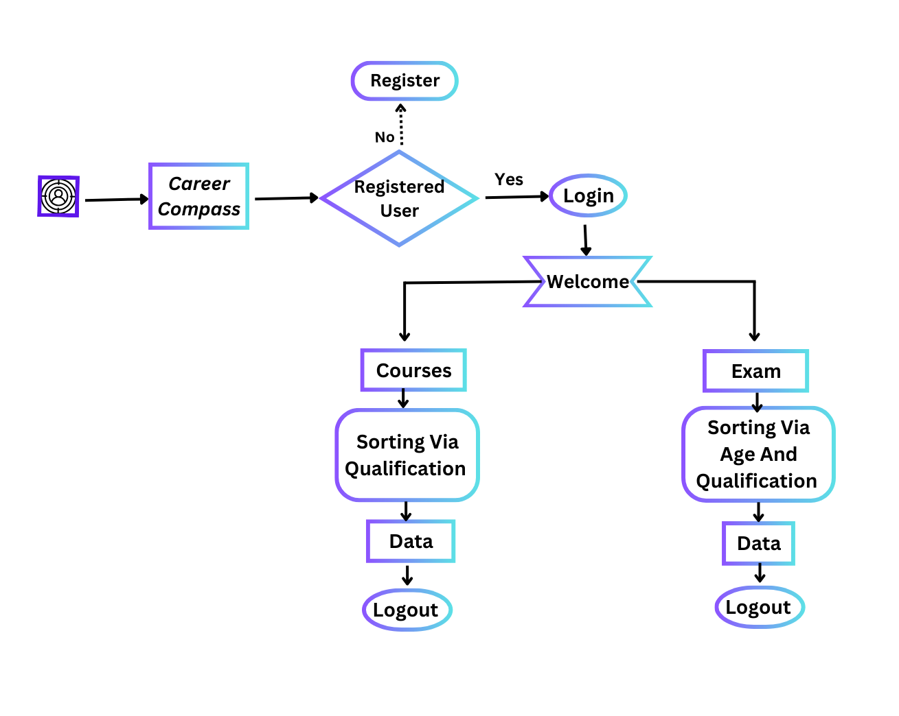

**Figure-1**

**System Architecture:**

The System Architecture of the Career Compass is neatly organized and it works smoothly with the key components includes,

**i) User Interface (UI):**

The user interface i.e. front-end development of Career Compass is made up of a powerful framework library of JavaScript, React.js. This framework provides attractive and interactive user interface for the front-end developers.

**ii) Backend Services:**

The server-side rendering of the L-Chat application is provided by the Node.js, and the backend is hosted by Express.js and the user data are stored and retrieved by a powerful database MongoDB. These together manages user requests, session management, Data Handling etc.

**iii) AI model:**

Incorporates language model Llama-3 provided by the Organization Meta. This is a powerful and reliable AI model and it is also restricted with keywords related to education, courses and career. This will be helpful for the application to not reply for unrelated topics.

**2.Front-End Development:**

**Framework: React.js**

**1.Welcome and Home page:** The initial interface where users interact with the application. It displays the end role that the application going to perform and allows users to explore about Career Compass.

**2.Forms:** In the Career Compass there are two forms out of which one is the course form other one is the exam form each are displayed in their respective web page. These forms are created through the framework React.js.

**3.Data Transfer:** The input data provided by the user is transferred from one component to another component using famous React technology called Context API.

**4.User credential:** A section where users can login or register their email id and password is inputted through react form and stored into the database MongoDB in backend

#### 3. Integration with Backend Services

The front-end needs to communicate effectively with the backend to retrieve data, send user inputs, and receive responses.

* **API Requests:** **Axios** or the Fetch API is used to make HTTP requests to the backend server. This includes sending user messages, retrieving responses, and managing user profiles.
* **Authentication:** Secure authentication mechanisms, such as JWT (JSON Web Tokens), ensure that user sessions are secure. The front-end handles login, logout, and token refresh processes.

**5.CONCLUSION AND FUTURE SCOPE:**

**CONCLUSION:**

Career Compass application will surely be helpful for Students and Youngsters by providing tailored, organized, and neatly displayed course and exam data for users. As this application is made with the technology React, it is more user-friendly and with best User Interaction ever. Hence this is all about the Career Compass.

**FUTURE SCOPE:**

The future scope of Career Compass is vast and promising, with several avenues for enhancement and expansion:

1. **Enhanced Data integration**: Future iterations could incorporate more advanced data adding features, such as real-time data fetching from the web, to further enrich user interactions.
2. **Improved Personalization**: Leveraging machine learning algorithms to analyse user behaviour more deeply could enable even more precise personalization of responses and recommendations.
3. **Language Support**: Incorporating support for Bi languages like English and Tamil would make Career Compass accessible to a broader audience, enhancing its inclusivity and reach.
4. **Enhanced Security and Privacy**: Implementing advanced encryption techniques and compliance with global data protection regulations would further secure user data and build trust.

**6.REFERENCES:**

[1] **"A Hybrid Approach for Career Path Recommendation Based on User Profile and Job Market Trends"**

* **Authors**: A. S. Akinyele, M. K. Lee, and J. Y. Ko
* **Description**: This paper explores a hybrid recommendation system combining user profiles with job market trends.

[2] **Adaptive Career Guidance System Using Machine Learning Techniques"**

* **Authors**: P. T. Kambhampati, R. B. Kher, and D. L. Giri
* **Description**: Discusses using machine learning to adapt career guidance systems to user preferences and aspirations.

[3] **Career Path Prediction and Recommendation Using Data Mining Techniques"**

* **Authors**: C. L. Lai, T. L. Chang, and Y. C. Lin
* **Description**: Focuses on predicting and recommending career paths using data mining techniques.

[4] **"Web-Based System for Career Counselling Using Natural Language Processing and Text Mining"**

* **Authors**: S. M. Tariq and N. M. Mian
* **Description**: Develops a web-based career counselling system using NLP and text mining.

[5] **"A Recommender System for Career Guidance Using Collaborative Filtering and Content-Based Approaches"**

* **Authors**: D. J. Armstrong and K. J. Hargrove
* **Description**: Presents a recommender system combining collaborative filtering with content-based methods.